Answers
1. One characteristic of robots is that they have electrical components.
(a) Name two other characteristics of robots. [2]
A mechanical structure (1) / a framework (1)
Programmable (1)
(b) Identify two electrical components that a robot is likely to contain. [2]
Sensors (1)
Microprocessors (1)
Actuators (1)
2. One area where robots are used is in doing domestic activities and chores.
(a) Give two other areas where robots are currently used. [2]
Industry (1), Agriculture (1), Medicine (1), Transport (1)
Accept other industries that use robots such as military.
(b) The below images show a manual batter-operated lawn mower and a robotic lawnmower.
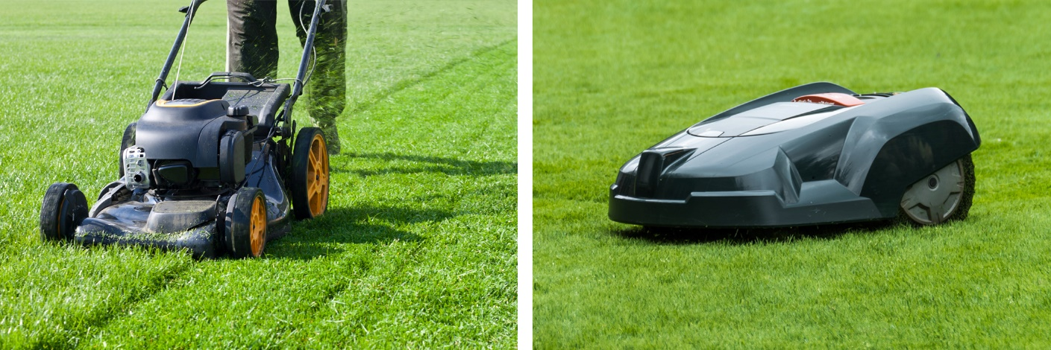
Compare a manual battery-operated lawn mower with a robotic lawnmower
by giving two similarities and two differences. [4]
Up to 2 marks for similarities and up to 2 marks for differences.
Similarities
Both have moving parts. (1)
Both units move over the lawn. (1)
Both cut the grass blades in a similar manner. (1)
Both have electronic components. (1)
Both need recharging. (1)
both have a mechanical structure / framework. (1)
Differences
The robotic lawnmower doesn’t require a person to operate it. (1)
The robotic lawnmower will choose its own route to cut the grass. (1)
Safety mechanisms on the manual mower will be made to help the user stop the mower safely, whereas those on a robotic lawnmower will be focussed around the robot detecting an issue so that it can stop. (1)
The robotic lawnmower is programmable. (1)
Accept other accurate and appropriate similarities and differences.

(c) Give two advantages and two disadvantages of using a robotic lawnmower. [4]
Advantages
It frees the person/gardener to do another job or have more free time. (1)
The robot can cut the grass many times a week keeping it good condition all the time. (1)
The robot doesn’t require a handle for the user to push it, so will likely be smaller / take up less space. (1)
The robot may be able to cut the lawn more efficiently resulting in lower energy usage. (1)
Disadvantages
A person may become less fit if they don’t have to do anything physical. (1)
A gardener/person may lose their job. (1)
It is expensive to buy. (1)
The person may enjoy cutting the grass so lose something they enjoy doing. (1)
It needs to be able to access a power source to charge it. (1)
It may be more expensive to repair. (1)
Accept other appropriate advantages and disadvantages.

[Total 14 marks]

